**Vr website**

**Colour palette:**

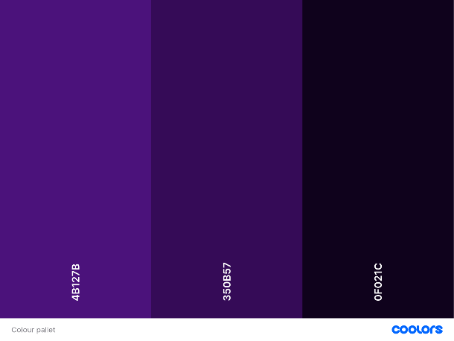

**Home page :**

**Headline:** “Visualize before you build “!  
**Subtext:** Step into a new dimension of architectural visualization—see, feel, and experience your dream space before construction begins.  
**CTA Button:** [Register for Demo] (Triggers pop-up form)

**Note**: Add a realistic 3d image as the background image on the home page.

**Explore Our Designs:**

* **Interior Design**Bring your interiors to life with our AR/VR technology. Experience lighting, textures, and furniture placement in a fully interactive 3D environment before making decisions.
* **Exterior Design**Visualize the exterior aesthetics of your home with real-time weather simulations and material customizations. Get a complete view before the first brick is laid.
* **Home & Kitchen Design**Design your dream kitchen and living space with a precise layout. Adjust placements, colors, and finishes to match your vision seamlessly.

**About Us**

At **Viruzverse**, we redefine architectural visualization using cutting-edge 3D AR/VR technology. Our goal is to help builders, architects, and homeowners experience their projects in real-time, immersive detail before construction begins. With hyper-realistic rendering, interactive walkthroughs, and seamless customization, we bring your blueprints to life.

* Next-Gen AR/VR Modeling
* Customizable Virtual Walkthroughs
* Seamless Integration with Construction Plans